Divorce in Canada & the impact on children
Some statistics
- The expected percentage of divorce for recent marriages (ending before their 30th wedding anniversary) has increased slightly from 36.1 % in 1998 to 37.9 % in 2004, and 38% in 2008. Essentially 2% since you were born.
  - This differs from province to province
  - The lowest rates are in Newfoundland [21.6%] and the highest rates are in Quebec [48%]
- However, these rates include repeats, in 2005 16% of divorced men had already divorced once before – same for 15% of women.
  - Probability for divorce is higher for remarriage than for first marriage
- Rates for first marriage are closer to 33%
Up or down?
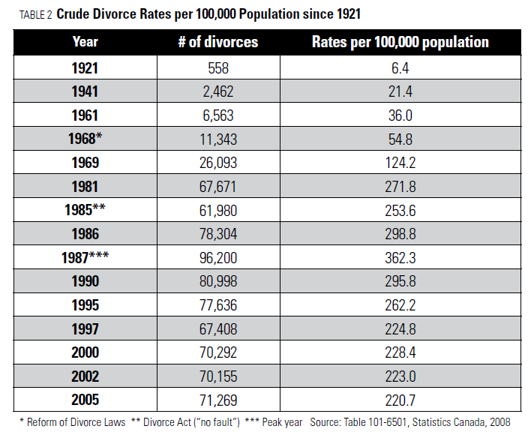
- Divorce rates dropped substantially in the 1990s and have remained at this lower level with minor yearly fluctuations.
Especially when you look at Crude Rates per 100 000
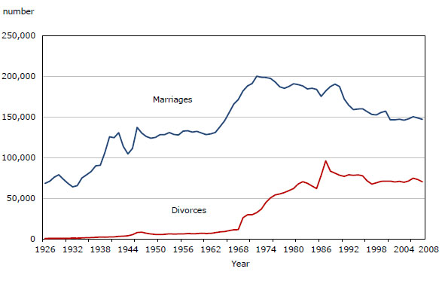

- 1968 _______________________________
- 1985 _______________________________
- 1987 _______________________________

Which way are we going?
- Whether rates will go up or down depends on socio economic, political, cultural & demographic ___________________
- as well as individual preferences & ________________________
Why it may start to increase…
- Risk factors for higher levels of divorce include whether or not couples _________________ and whether or not their ___________________________
  - More young people plan ______________________________________
  - There are more “_____________________” today who will be growing up and marrying in the future
What about the children?
- Research shows that some children adjust to their parents’ separation or divorce better than other children.
- The 2 most salient (notable) negative consequences of divorce are…
  - an increased risk of poverty
  - an increased risk for the development of problems for the children involved
1. An increased risk of poverty
- The economic resources available for parenting are often ________________after divorce
  - divorced women and their children are the ____________________________________ people in Canada
  - within 2 years of a divorce /separation ______% women had experienced a decrease in household income compared to ____% of men [conversely a rise by 9% of women and 29% of men]
    - However, in a decade where most families have two breadwinners, men who divorce lose far more financially than in the past, especially those married to high earning women
- For families already burdened by poverty – _________________________________________
  - The _____________________ the children are at the time of divorce the more likely they are to be poor
  - ______________________________ have an income that is 40% below the poverty line* – DIRE POVERTY
  - ____% of all female lone parent families lived in poverty in 2004 while many hovered just one step above
LICO Low Income Cut Offs
- This is a measure that changes based on the ____________________________
- It is what the “_______________________” is measured by, families that make ___________________ than this are considered to be living in poverty

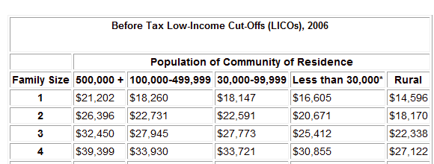

Before Tax Low Income Cut Offs (LICO), 2010
3 | $34, 646 | $29, 836 | $29, 652 | $27, 132 | $23, 849
4 | $42, 065 | $36, 266 | $36, 003 | $2632, 943 | $28, 957

2. An increased risk of problems for children
- Although most children do ____ experience serious problems as a result of divorce, it is a strong risk factor and a ___________________________
- Divorce is above all, an ___________________________ transition that can create lingering feelings of sadness, longing, worry, and regret that __________________________ psychological and social functioning
- Average differences ___________________, but children whose parents are divorced are more likely to
  - Suffer from __________________, anxiety & other emotional disorders [ 10 of 14 girls and 4 of 13 boys at FFSS according to Metheral (2014) ]
  - Exhibit _________________________ including hyperactivity, aggressiveness, fighting and hostility
  - Become _____________________
  - Do ______________________ and remain in school for a shorter period of time
  - Experience ________________________________________
- _______________ whose parents divorced during their childhood and teen years, tend to…
  - Have a _________________ (not married) more often, particularly during adolescence
  - Achieve ____________________________
  - Be more often __________________________________________________
  - Have more _____________________________________________
  - Are more likely to have _________________________________ and to report a less happy childhood
  - ____________________________________ (affects schooling due to money)
Important note…
- Some of these negative effects would have _____________________ before the divorce
- Many of these consequences are actually ______________________________
- They do ____________________________________, they are only at a greater risk of developing problems
- There is a _____________________________________________________

Sources of these negative outcomes
- Poverty
- Diminished parenting
- Parental conflict
- Pre existing problems
- Genetics

Poverty
Typical negative outcomes of children of divorce essentially resemble
those of children in poverty
Additional stressors may include…
- needing to ___________________________________________
- ____________________________________ or living conditions
- ___________ neighbourhood, more delinquency
- ______________________________________________________
- possibly more noise and pollution
- children and ____________________________ may be affected
- more _______________
- parent who works long hours to make ends meet and is __________________________
Diminished Parenting
Diminished parenting occurs when divorce creates a series of stressors particularly
for the custodial parents
Some abandon responsibilities and some become “pals”

This can result in parent(s) who are…
- ______________________________________________
- suffering from _______________________
- spending time looking for a new mate and therefore ______________ _____________________________
Also, can result in stressors and preoccupations that diminish…
- ________________________________________________________________________________
Also, can result in increased…
- ________________________________________________________________________________
Parental Conflict
Parents who continue or begin quarreling & verbally abusing each other in front
of their children cause ________________________________________________
When children are caught in the middle, this can result in…
- _________________________
- _________________________
- Aggressiveness & other ___________________________
Parental hostility during the marriage provide unhealthy role models
- Children ___________ that disagreements can only be solved by fighting
___________________________ can occur when one parent more or less brainwashes a child against the other & prevents that parent from seeing the child and the child from loving that parent
- this can have dire consequences for the child’s ____________________ in the future
Divorces that ____________________________________________________________________________ for children
However, when the parents are __________________________ is seen by the child as very __________________________________
_______________________________________________________
- It also indicates a __________________________________ or which may not be the best example for the child for their own future relationships
Pre-existing Problems
- Some parents already have a ____________________________________ which has been negative for the children,
  - This _________________________________ when the parents separate
  - Parent may ______________________, troubled personality
- Divorce just seems to make this ___________________
Genetics
Lastly, a proportion of people who divorce do so because they are _______________________________, _____________________________ people
- These parents pass on these _______________________ to any biological offspring
- These children run the risk of being __________________________________________, and then live in a conflict ridden home that is disorganized, and fosters their negative predispositions
- When divorce happens in these situations the _____________________________ and the ___________________________________ – vicious circle
BUT.. Nothing is fixed in stone!

Does Age or Gender Make a Difference?
- Early research seemed to indicate that ______________ might experience _____________________ than girls.
  - Children between the ages of ______________ may be the most negatively affected because they are _________________________________________ and their changing family situation.
  - In the ______________________________, boys are more likely to be aggressive and get into fights,
  - while girls are more likely to ______________________________.
- But by _________________________, both boys and girls are more likely to engage in negative conduct and experience bouts of sadness.
  - Adolescent girls are likely to be involved in ___________________________, leading to a greater risk of teenage pregnancy and teen parenting,
  - Then there are some girls who emerge out of the divorced, mother-headed households as exceptionally _____________________________.
  - This is true for ____________________________.
Debates are on-going about the negative effects and the extent of the damage… Some conflicting findings…

Wallerstein vs Hetherington
Judith Wallerstein  - ____ of all children suffer serious long term consequences from their parent’s divorce  - poor social and emotional development, poor school results, substance abuse and having their own marriages end in divorce, affects a child’s ability to trust others and makes it difficult for them to commit | E. Mavis Hetherington  - children of divorce can be divided into _______ groups… winners, survivors and losers  - losers thankfully are the ____________ of the groups according to her research  - research show that after _____________ the majority of children of divorce are functioning reasonably well  - her studies reveal that for every young adult from a divorced family who is experiencing problems, there are four who are not  - Her statistics show that ____% of children of divorce have serious social, emotional, or psychological problems, compared to ____% of children who come from intact homes  - Most single mothers are  providing ______________  for their children & should  be celebrated

Parent’s ability to co-operate
- Parent’s ability to ___________________ affects the ________________________ of the children
- Divorces can be characterized by parents who are either
- High conflict
- Business like
- Friendly
- Parents who are ____________________________ cause a lot less stress for their children and therefore less trauma

There is no such thing as a typical divorce
- Each family goes through their own process
- Some find it really hard while others find it a new beginning
- It is a developmental process that unfolds over time
  - it begins when parents begin to contemplate divorce, continues through the divorce till the creation of a post-divorce family
What really counts?
No matter what the family structure is it is the ____________________________________________ that is the most important factor in a child’s adjustment in life
- Children who have at least one positive, _____________________________ parent ______________________________ are likely to be competent and well-adjusted during childhood and later in life

