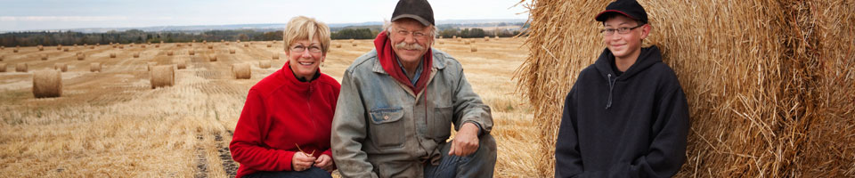
Family Life Cycle Stages
Matching Game

Match the function of the family with the most correct example.
- Physical maintenance and care of group members | - Susan and Sanjay are expecting their second baby in December.
- Addition of new members through procreation or adoption | - Susan and Sanjay regularly tuck in their 4 year old, Keiran with kisses and hugs and a bed time story.
- Socialization of children | - Sanjay makes sure that Keiran has been to the doctor and had all of his vaccinations and checkups.
- Social control of members | - Susan goes to work at a car plant where they manufacture ford trucks. Sanjay shops for groceries at the local Food Basics.
- Production, consumption, distribution of goods and services | - When Keiran stole a chocolate bunny from the drug store, Sanjay made him take it back and apologize to the store owners.
- Affective nurturance – love | - Sanjay has explained to Keiran that it is not good to call other children bad names or to push them off the slides; instead they help him to learn good manners.

Answer Key
- C
- A
- F
- E
- D
- B

http://zel.me/FDSqUM
http://www.kitzkikz.com/flashcards/output_pdf.php?id=FDSqUM&submit=View+PDF
http://worksheets.theteacherscorner.net/make-your-own/crossword/crossword.php

