Family in Later Years
Main Task:
Accepting the shifting of generational roles
Subtasks
- Maintaining _______________________________ and interests in the face of physiological ____________________, exploration of new familial & social role options
- Support for a more central role for ___________________________________
- Making room for the __________________________________, supporting them without over functioning for them
- Dealing with ________________________, siblings and other peers, and preparation for own death /Life review and integration
- Canada has an aging population, the proportion of elderly to other age groups in the population __________________________
- During the 1960s seniors (over 65) made up ____% of the population, now it is closer to ____% and it will reach ____% over the next two decades
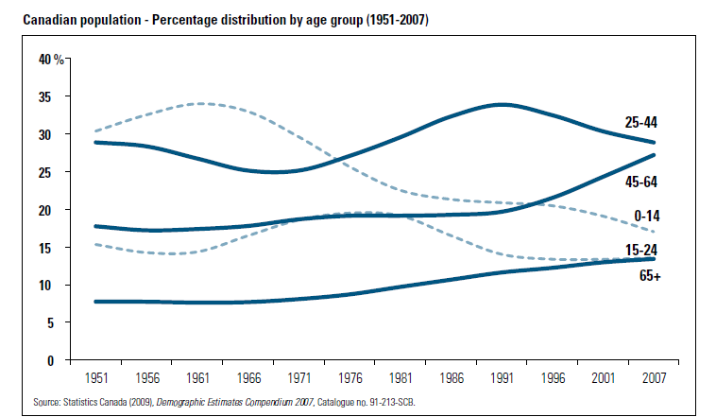
- Women live ____________________________ and are more likely to be widowed and subsequently more likely to be living in poverty than men
  - __________ ratio women and men over the age of 65 in Canada
  - At every other age grouping the ratio is closer ______________
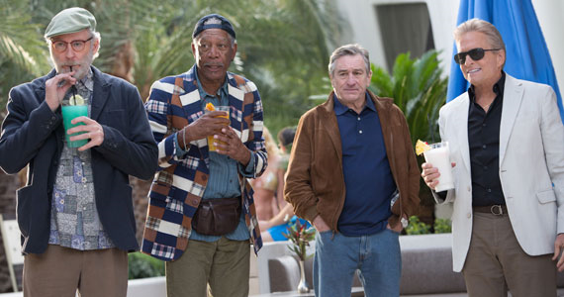
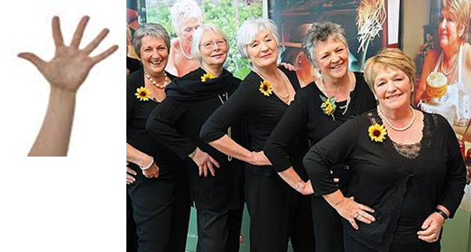

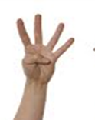
- There is an impetus (push) toward helping the elderly stay in their homes and to have children support their elderly family members- however there are limitations to the care that families can expect to provide
- Why are we increasingly concerned about families in middle and older ages?
- We don’t have a lot of research from past or present about midlife , midlife families or aging and the elderly
- Midlife families and the elderly are _____________________
- We want to have a better understanding of stressors, rewards, and experiences of today's mid lifers and elderly
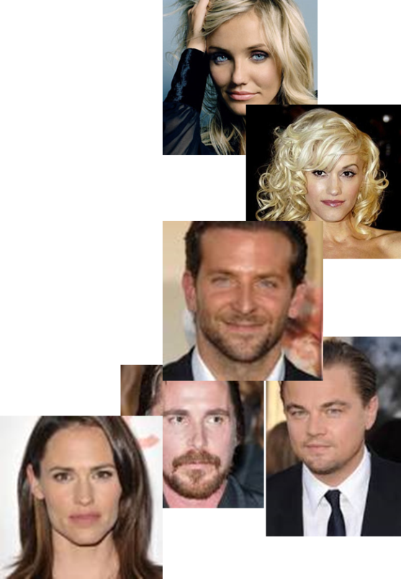
- We are interested because the ____________________________ is now in midlife and aging into the early stages of being elderly
- Why is middle aging a changing social construct? How do you think it might change in the next decade or two?
- The average life expectancy is increasing which places the mid-point or _______________ to a different position
- Today in Canada, midlife is _____ for men & _____ for women
- We don’t look our age en masse – there are lots of variations…
- We are more likely to spend _______________ taking care of our parents than our children
- We are more likely to live a long time with our adult children ____% women and ____% men aged 35 to 54 still have kids at home
There is a wide range of lifestyles today for the middle aged in Canada,
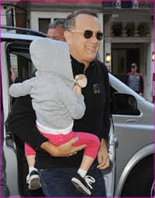
Some are…
- Becoming __________________
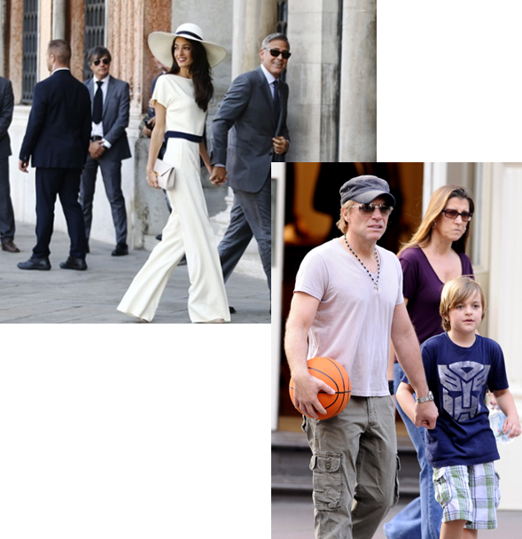
- Becoming ____________________
- Starting _____________________
- Continuing __________________________
- Ending current relationships
- Reentering the work force after raising children
- Scaling back on work
- Looking after both children and aging parents
- How is aging different for men than women in families? Do you think this is changing? How?
____________________________________________________________________________________________________________________________________________________________________________________________________________________________________________________________________________________________________________________________________________________________________________________________________________________________________
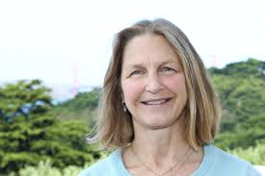
- Women are more likely to live in poverty due to
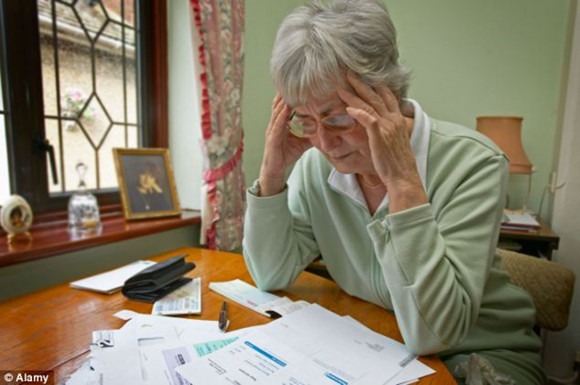
  - less financial security &__________
________________
  - lower pensions
  - ______________ to x partners pensions and savings
  - economic uncertainty because of
_______________________
- Women are more likely to be care givers and these responsibilities affect job security, retirement, well-being, and they are less likely to get help, care giver burnout
- Men are more likely to have savings and better job security
Consolidation…
What is the take away from this? What are some of the key ideas?
__________________________________________________________________________________________________________________________________________________________________________________________________________________________________________________________________________________________________________________________________________________________________________________________________________________________________________________________________________________________________________

