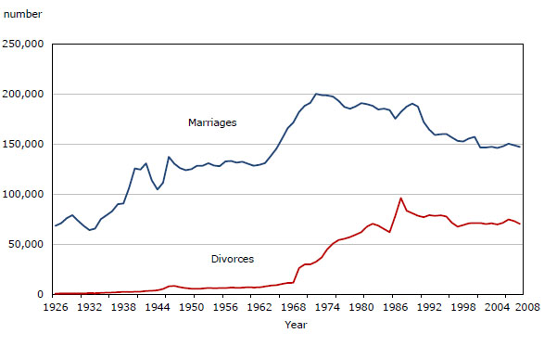
Family Trends
↑ Up or Down ↓

Place the trends that are increasing in the up column and the ones that are decreasing in the down column and so on.
↑ Up | Down ↓ | same

fertility skip generation families Canadian income
age of a woman when she first marries divorce male contributions at home
age of a man when he first marries common law hetero families dual income families
child poverty same sex marriages
lone parent families same sex families with children
lone parent mother family ratio blended families
monogamy globally number of families in Canada
family size hetero married families
common law same sex families age that children launch
aging families inequality between the “haves” and “have-nots”

underline means this is relatively new direction for this trend or a new trend

Up
fertility skip generation families
age of a woman when she first marries divorce male contributions at home
age of a man when he first marries common law hetero families dual income families
same sex marriages Canadian income same sex families w children
blended families monogamy globally number of families in Canada
age that children launch aging families
inequality between the “haves” and “have-nots”

Down
family size hetero married families
common law same sex families child poverty

Same
lone parent families lone parent mother family ratio

