From Freud to Baumrind:
A Selection of Child Development
Sigmund Freud • Erik Erikson •
Maria Montessori • Jean Piaget •
Abraham Maslow • John Bowlby •
• B.F. Skinner • Benjamin Spock •
Diana Baumrind •
& Parenting Theories
Sigmund Freud (1856-1939) Psychoanalytic Theory
The unconscious ___________________________________
- Individuals go through ____________________________
that shape their adult personality.
- Behaviour is influenced by the __________________________.
- ___________________________________________, affect development in later life.
The ___________________________________ of a child is complex.

Psychic Life Functions:
- ID - present at birth; directs need gratification; pleasure seeking; and pain avoidance.
- EGO - Responsible for contact with day to day reality; predicts probable outcomes of behaviour choices.
- SUPEREGO - Internal interpretation of the rules and values of the environment.

Stage Theory of Psychosexual Development:
- Going through each stage can result in either _______________________________________
or can result in failure, leading to an unhealthy personality.
- ______ Stage (Birth to 18 months).
- ______ Stage (18 months to three years).
- ______ Stage (ages three to six).
- ______ Stage (age six to puberty).
- ______ Stage (puberty on).
Oral Stage (Birth to 18 months).
- Child is focused on ___________________ (sucking).
  - Too much or too little gratification can result in an oral fixation
which is evidenced (shown) by a preoccupation with oral activities.
  - This type of personality may have a stronger tendency to smoke, drink alcohol, over eat, or bite his or her nails.
  - Personality wise, these individuals may become overly dependent upon others, gullible, and perpetual followers (sheep).
  - On the other hand, they may also fight these urges and develop
pessimism and aggression toward others.

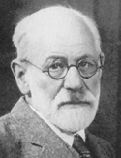

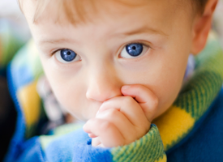

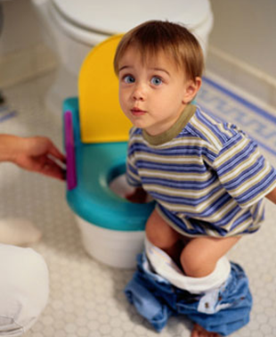
Anal Stage (18 months to three years).
- Child’s focus of pleasure is on eliminating ___________
__________________________.
  - Through society’s pressure, mainly via parents,
the child has to learn to control anal stimulation.
  - In terms of personality, effects of an _________________
during this stage can result in an obsession with
cleanliness, perfection, & control (___________________).
- Or on the opposite end of the spectrum, they may
become messy and disorganized (__________________).
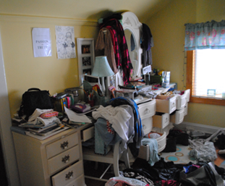

Phallic Stage (ages three to six).
- The pleasure zone switches to the __________________.
- Freud believed that during this stage boys develop _________________ sexual desires for their mother.
  - Because of this, boys become rivals with their fathers and see him as competition for their mother’s affection.
  - During this time, boys also develop a fear that their father will punish them for these feelings, such as by castrating them.
  - This group of feelings is known as ______________ Complex (after the Greek Mythology figure who accidentally killed his father and married his mother).
  - The female version of this is known as the ____________ Complex.

Latency Stage (age six to puberty).
- It’s during this stage that sexual urges remain _______________ and children interact and play mostly with same sex peers.
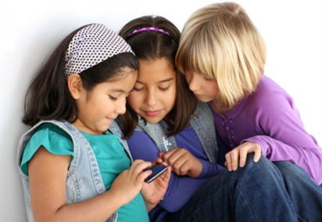
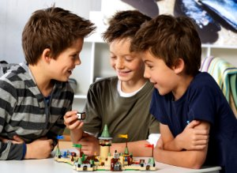

Genital Stage (puberty on).
- The final stage of psychosexual development begins at the start of ___________ when sexual urges are once again awakened.
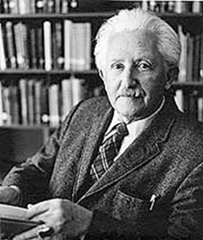
- Theoretically, (______________________) through lessons learned during the previous stages, adolescents direct their sexual urges toward opposite sex peers, with the primary focus of pleasure is the _________________.
Erik Erikson (1902-1994) Psychosocial Theory
There are stages of _________________ development.
- Humans develop throughout their life span in ___________________.
- As we grow, the goal is to develop a _______________________________.
- The development occurs through _______________________ which affects ______________________ development.
- At each stage, there is a task that the individual “________” or “__________”.
  - If an individual does not come out on the winning side of a stage they still proceed to the next stage based on age and chronology.
  - The results of one stage may _____________________________ at the next.
  - However some argue that the consequences may be alterable later in life.
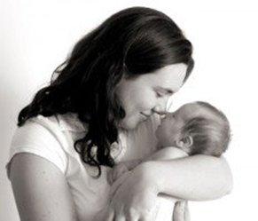
Psychosocial Stages:
- Trust vs. Mistrust (0-12 to 18 mos.)
  - Infant forms a loving, __________________________________
or is frustrated and lacks self-confidence.
- Autonomy vs. Doubt (18 mos. to 3 years)
  - Child needs to develop _____________________ with firm,
gradual and kindly support of parents so the child does not lose
self-esteem.

  - Initiative vs. Guilt (4-6 years)
    - Child gains skill in language and exploring and
needs guidance from parents to proceed in life
in a self-confident____________________.
- Industry vs. Inferiority (7-12+ years)
  - Child pursues and completes activities that produce
something and gain recognition from parents, teachers
and friends. Failure makes the child feel inadequate
and inferior.
- Identity vs. Role Confusion (12-18 years)
  - The sense of “___________” and what part I play in society
(occupation, politics, sex roles, religion, etc.) is determined.
Parents have new expectations for the adolescent. Those
who ___________________________ of who they are, may
be ____________________________________________.
(There are more stages for adults, not shown here.)
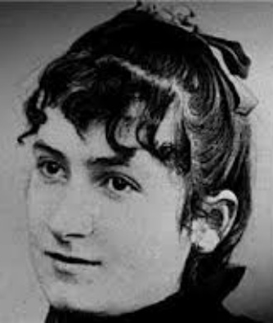
Maria Montessori (1870-1952)
Parents as Early Educators
Parents ___________ their children’s development.
- Each child has an ________________________.
- Children should be guided with love and affection to expected behaviour.
- Children should __________________________________ to learn how to care for themselves and a home.
- Parents should be aware that ____________________________________________.
- Parents should ________________________________________________________.
- Parents should encourage their child to do as much as possible on their own.
- Does this coincide with Freud or Erikson in your opinion? _______________________________
Why? ____________________________________________________________________________
_________________________________________________________________________________

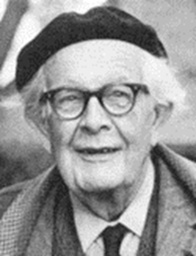
Jean Piaget (1896-1980) Cognitive Development Theory
Understanding & supporting a child’s learning.
Two processes are essential for development:
Assimilation
- Learning to understand events or objects, based on _______________.
Accommodation
    - ___________________________, ______________________________.
Sensorimotor (Birth – 2 years)
  - Learning about world through ____________________ (see, feel, hear, smell & taste).
  - ~6 months develop the concept of object permanence (objects that disappear still exist in reality).
  - Learning to control and manipulate muscles (small & large motor skills).
  - Learning about self (_____________________).
  - Learning from trial and error (12-18 months).
  - Thinking about how to do something without actually doing it.
Preoperational (2-7 years)
  - Learning by using language and _______________________________.
  - Learning to internalize thought process.
  - Continuing to be egocentric.
  - Learning by _______________________________________.
Concrete Operational (6 or 7-12 years)
  - Learning to understand ___________________________________.
  - Learning to resolve problems with logic.
  - Learning ______________________ (amounts of liquid remain the same, even if the shape changes).
Formal Operations (13 years – adult)
  - Thinking logically, _____________________, and ____________________________.
  - Testing theories by hypotheses.
  - Understanding right vs. wrong.
  - Glimpse of complexity of knowledge in teens leads some to believe they understand nothing and others to believe they are on the verge of understanding everything.
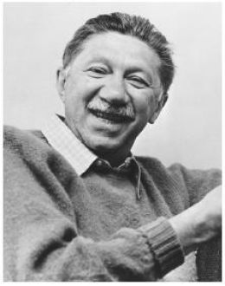
Abraham Maslow (1908-1970) Human Needs Theory
Human ____________________________________________.
- Humans have a _________________ of needs and this
motivates behaviour and the acquisition of these affects
personality.
  - for example - a person who is busy trying to get affection and acceptance, but is not very successful, may become more of an introvert, or may become more passive and agreeable if they think this is needed, or may become easily influenced by others, or conversely, a person who has all the love and acceptance they need from their family and friends, may be very confident, have a high self-esteem and be less easily influenced by others.
- Lower needs must be filled before upper-level needs receive attention.
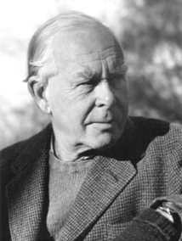
- Child’s genetic potential will not flourish unless they are nurtured by adults as they grow.
John Bowlby (1907-1990) Attachment Theory
Bonding is an essential part of development.
- Parent’s ability to adjust and accommodate to their child’s behavioural
style is the key determinant of a child’s attachment to a parent.
  - If a parent is warm and responsive then a child will be securely attached (cry when parent leaves, then greets parent happily upon their return).
  - If a parent is not sensitive or responsive then the child will be anxious avoidant (rarely frets when parent leaves and avoids the parent when they return).
  - If a parent is inconsistent, sometimes responsive, sometimes not, then the child will be anxious resistant (frets before parent leaves, seeks contact when parent returns, but also resists contact by pushing away).
- Which other theories does this concur with in your opinion? ___________________________
Why? ____________________________________________________________________________

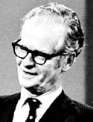
B.F.Skinner (1904-1990) Operant Conditioning
Parents play a role in ________________ behaviour.
- Emphasizes the role of the parent in _____________________
(__________________) the child’s behaviours.
- Consequences of a behaviour lead to changes in
its _______________________.
- Behaviour patterns will change if the child is rewarded, ignored or punished.
Conditioning functions:
  - ______________ behaviour - reinforcing a behaviour “close” to the desired behaviour.
Consequences include:
  - _____________ reinforcement - something that causes an act to increase in the future, i.e. a child smiles and gets a hug.
  - ____________ reinforcement - child causes unpleasantness to cease, i.e. parents “lecture” stops when child cleans room.
  - ____________- unpleasant act by parent discourages behaviour
in the future, i.e. T.V. privileges taken away or spank.
Limited to only the specific behaviour – it does not cause the child to reflect on other behaviours or actions necessarily
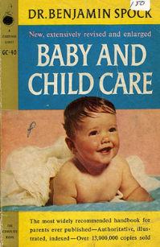
Benjamin Spock (1903-1998) Baby and Child Care
Encourages parents to _______________________________________.
Parents should:
- Understand there are great ___________________ between individual children — and that some children are more difficult than others.
- Understand that __________________________ that should be met.
- Understand that it’s _____________________________.
- _________________________________ their children and ________________ to them.
- Feed babies _______________________________.
- Let their tired babies cry, after checking to make sure they aren’t hungry, cold or need a diaper changed.
- Understand there is a need to be flexible and responsive to baby’s needs.
Diana Baumrind (1926- )Parenting Styles Theory
The _________ parents set limits & love their children _________________ their development.
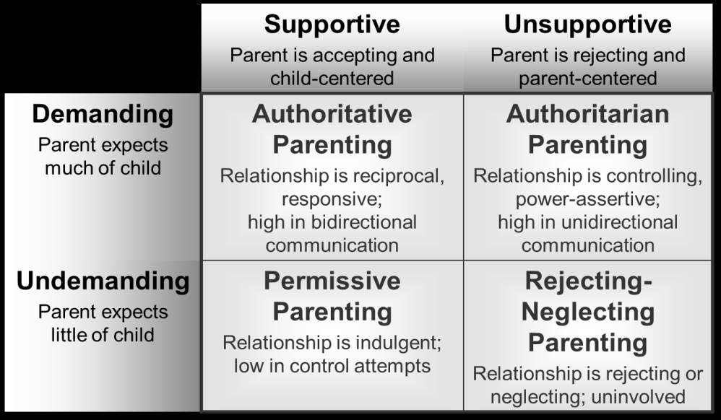
Which of these four styles do you think is the most effective?
__________________

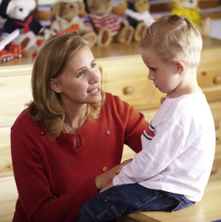

The four parenting styles and their ____________on the child

The Authoritative parent is…  affectionate, engaged, sets limits and enforces consequences  uses logic, reason and appropriate negotiation  empowers a child’s decision making | His or her child is likely to be…
The Authoritarian parent…  is emotionally aloof, strictl and in charge, likes to say “Because I said so”  uses physical punishment  is not overly concerned about a child’s feelings | His or her child is likely to be…
The Permissive parent…  is affectionate, anxious to please, ends every sentence by asking “OK?”  is indulgent, cannot say no and stick to it  is easily manipulated | His or her child is likely to be…  demanding and whiny, easily frustrated  lacking kindness and empathy (spoiled)  a poor to average student, a follower
The Passive parent…  is emotionally removed or indifferent  is uninvolved, abandons discipline  is inconsistent and unpredictable | His or her child is likely to be…
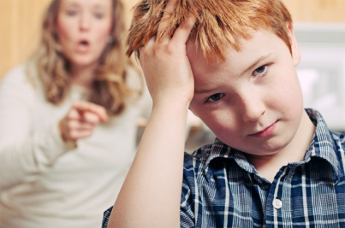

Consolidation - Who am I Quiz?
- My theory states that human needs must be met at more basic levels before they move up to more complex levels. _____________________
- My theory states that children learn cognitively at four distinct levels. _____________
- My theory lists stages people travel through during their entire lifetime. _____________________
4. I believe that early interactions with parents impact children’s personality
development. _____________________

