Love & Attraction Theories
- Kerckhoff and Davis Filter Theory
- Murstein’s Stimulus . Value . Role Theory of Attraction
- Aron & Aron Love as Self Expansion
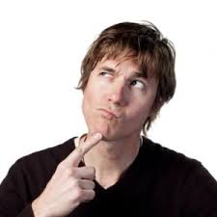
- Sternberg’s Triangular Theory of Love

Minds On
How do you think we sort out who we might partner with?
_______________________________________________________________________________________________________________________________________________________________________________________________________________________________________________________________
Kerckhoff and Davis’ Filter Theory
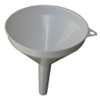
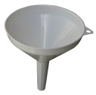

- We start off with a ______________________________________________________________
- We begin to filter people out based on ___________________________________________ _________________________which makes the pool of possibilities ____________________
- Then we filter people out by ____________________________ which makes the pool smaller again
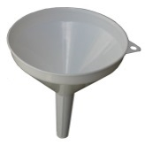
- Last we filter them out based on ________________________ which leaves us with fewer choices again
Murstein’s Stimulus . Value . Role Theory of Attraction
- Builds on both the ________________________ and ____________________________________________
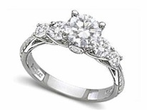
- the filter theory states that we go through a multi stage filtering process of elimination to find a mate as __________________________ we go there several stages or processes of elimination
- The social exchange theory states we ________________________based on costs
and benefits
- Stimulus Stage
- first stage is ________________________
- partners start a partnership because of physical attraction, social compatibility and other factors that are screened for or ________________________
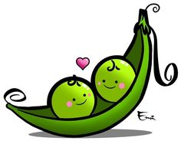
- if the rewards or benefits of the partnership are ___________________________ then the relationship can proceed to the next stage
- Value Stage
- second filtering stage is ________________________
- get to know each other’s _________________________________________ etc.
the stronger the similarities (homogamy) the more compatible the pair
We’re two peas in a pod
- the more ________________________ probably the higher the rewards so
onward and upward to the next stage
- Role Stage
- third stage of the filter is ________________________
- the pair sees how __________________________________ & _______________________ ________________________
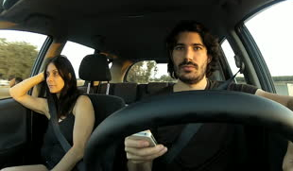
- the more interactions they have, the better idea they have of how marriage might be and the benefits or costs if the benefits appear to win out the couple may choose to stay together

Checking In
What three ingredients do you think are most
important for a successful intimate relationship?

1.____________________________________________________________________________2.____________________________________________________________________________3.____________________________________________________________________________ ___________________________________________________________________________
Aron & Aron Theory of Love as an Expansion of Self
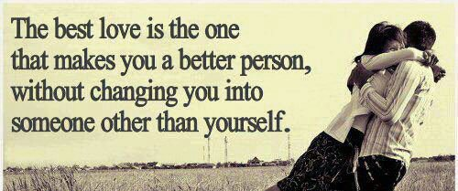
- Aron & Aron believe that _________________ is a
motivator of behaviour - including the behaviour
of _________________
- They agree with theorists that look at _________________
as a foundation for beginning a relationship
ex Kerkhoff & Davis filter theory and Murstein’s stimulus value role theory
- However they differ in that they allow for _____________________________
in the relationship…the whole idea of _________________
    - Allows for us to continue in a relationship with someone we
differ from
- The idea is that we view this as a ______________________ … hence the title “self-expansion”
    - Similarities don’t necessarily mean a lost opportunity for growth, but growing together would be necessary for the relationship to continue… the whole idea that you are sticking with the relationship for self-growth
intimacy
commitment
passion
Sternberg’s Triangular Theory of Love
- this theory is about a way of looking at a love relationship &
_________________ or assessing it.
- It is based on a _________________ where the three sides are commitment,
intimacy and passion.
- the more commitment, intimacy and passion there is in a relationship
the larger the triangle
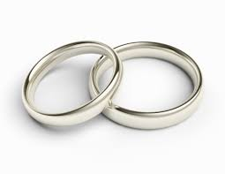
Commitment
- is both a _________________ commitment to love someone and a long term
commitment to __________________________________
- it grows slowly as two people get to know each other, & eventually levels off
- it remains at a _________________ _________________ _________________ but will decline if the relationship starts to deteriorate
Intimacy
- is _________________ _________________ it includes…
- looking out for the partner’s welfare
- __________________________________
- holding them in high regard
- __________________________________
- understanding
- __________________________________
- giving and receiving emotional support
- __________________________________
- valuing partner’s company
- ____________________________________, it slows down as partners get to know each other and can level off, there can be some drifting apart or growing closer. A crisis can be a test
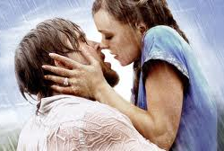
Passion
- Passion is the _____________________ of the triangle. It is the
__________________________ that brings them together.
- Early on in the relationship it ___________________________
- but is often not long lived. Sternberg compares it to an addiction – you get used to and need more of to get excited than usual – if you part you may have withdrawal symptoms etc.

Notes about the Triangle
- The bigger the better – size does matter here - ______________________. ________________________ __________________________
- The closer the triangle is to being an__________________________ the better and more ____________________________________________________
- Varying the _________________ produces different shapes that reflect _________________ relationships
- Relationships actually have several triangles – the actual (how it is for them), the ideal (how they wish it was) and the perceived (how they think it is seen by partner) the more similar the three triangles are the better

IDEAL
how
they wish
it was

PERCEIVED
how
it is seen by partner

ACTUAL
how
the person sees it

Some couples have __________________________of the sides of the triangle covered, to a stronger or lesser degree, by looking at the ways that these are combined we can determine the type of love they have

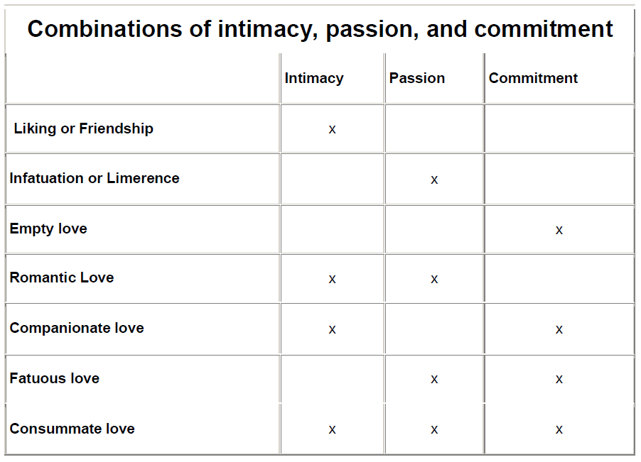
- Liking in this case is not used in a trivial sense. Sternberg says that this intimate liking characterizes ______________________, in which a person feels a bond, & a closeness with another but not intense passion or long-term commitment.

- Infatuated love is often what is felt as "______________________." But without the intimacy and the commitment components of love, infatuated love may disappear suddenly.

- Empty love Sometimes love in which there is ______________________________and passion. In arranged marriages, relationships often begin as empty love.

- Romantic love Romantic lovers are ______________________ (as in liking) and ____________________________________arousal.

- Companionate love is often found in marriages in which the passion has gone out of the relationship, but a ____________________________remain. Companionate love is generally a personal relation you build with somebody you share your life with, but with no sexual or physical desire. It is stronger than friendship because of the extra element of commitment. The love ideally shared between family members is a form

of companionate love, as is the love between deep friends or those who spend a lot of time together in any asexual but friendly relationship.

- Fatuous love can be exemplified by a ______________________ and marriage in which a commitment is motivated largely by passion, without the stabilizing influence of intimacy

- Consummate love is the ______________________of love, representing the ideal relationship toward which many people strive but which apparently few achieve. Sternberg cautions that maintaining a consummate love may be even harder than achieving it. He stresses the importance of putting the sides of love into action. Consummate love may not last. If passion is lost over time, it may change into companionate love.

The
balance
among Sternberg’s
three aspects of love
is likely to shift through
the course of a relationship.
A strong dose of all three components
-found in consummate love-typifies, for
many of us, an ideal relationship. However
time alone does not cause intimacy, passion, and
commitment to occur and grow. Knowing about these
components of love may help couples avoid pitfalls in their
relationship, work on the areas that need improvement or help them
recognize when it might be time for a relationship to come to an end.

