Marital Relationships
- 9 Psychological Task Needed for a Good Marriage
- 3 Stage Life Cycle of Marital Relationships
- Family Life Cycle;
- 10 Factors Affecting Marital Satisfaction

9 Psychological Tasks Needed for a Good Marriage

Judith Wallerstein ________________________________________who had been married for at
Least ___________________; had children together an independently saw their
marriages as happy. From this she discovered the following 9 psychological
tasks that she feels provide for a ______________________________________________________________…
- _____________________________________________________________________________________; not to the
point of estrangement, but enough so that your identity is separate
from that of your parents and siblings.
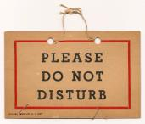
- Build togetherness based on a ______________________________________________________,
while at the same time set boundaries to protect each partner's autonomy.
- Establish a rich and pleasurable sexual relationship and protect
it from the ________________________________________________________________________________.
- For couples with children, embrace the _________________________________________
and ____________________________________________________________________________________. Learn
to continue the work of protecting the privacy of you and your spouse
as a couple.
- Confront and master the _________________________________________________________________________________.
- Maintain the strength of the marital bond in the face of adversity. The marriage should be ______________________________________________________________________________
_________________________, anger and conflict.
- _________________________________________________________________________ & to avoid
boredom & isolation.
- ____________________________________________________________________________, satisfying each partner's needs for dependency and offering continuing encouragement and support.
- __________________________________________________________________________________________________________________, while facing the sober realities of the changes wrought by time.

3 Stage Life Cycle of Marital Relationships

According to Hilary Goldstine, psychologist, author and relationship
counselor, there are ______________________________________of a marital relationship

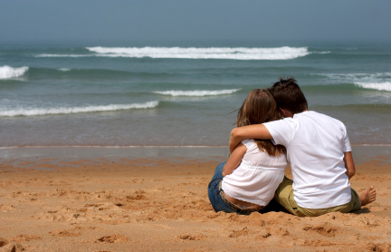
Stage 1 Happy Honeymoon Stage

The __________________________________, filled with positive
feelings, and putting our best self forward…
In this stage couples give and receive pleasure
and ________________________________________. They spend a
lot of time together, talking for hours,
supporting each other, and are responsive to
each other's needs. Each tries to achieve a close and harmonious relationship. In doing so, they establish a basis for a lasting relationship. But perhaps their
intimacy & harmony are achieved by _______________________________________________________________and disagreements that are inevitable in any close relationship.
People tend to present themselves in the best possible light to _________________________________
_______________________________ & win approval from their partner. They might be afraid the other would reject them if their true self were to become known. Also, they tend to ____________________________________________________________________.

Stage 2 Period of Conflicts and Regrets

A period of _______________________________________________________
with the inevitable stripping away of the masks or
facades of the honeymoon stage that comes with
__________________________________________________. The discrepancy
between what one thought, hoped, or expected
marriage would be like and its present ___________________________________________________________________,
hurt and bitterness. Too often, however, the ___________________________________________________________ is attributed to the other, so that mutual blaming can be frequent during Stage 4. The belief that "if only my spouse would change or be different, everything would be okay." is typical of this period.

Stage 3 Reaching an Accord (Agreement)

At this stage couples ___________________________________________
to each other. ___________________________________________- differences
and disagreements have been recognized and
worked through so that there is _____________________________________
___________________________________________. As a result, both partners
can comfortably be themselves and still feel loved and
accepted by the other. Stage 3 is based upon
______________________________________________________________________________________. Each partner strives to meet the needs of the other, and in return, expects his, her or their own needs to be met to a realistic degree by the other. This stage often requires work and effort on both sides.

Family Life Cycle Framework

Alternatively, some researchers find that it is a little more complex than 3 stages. They felt a better fit would include reference to the __________________________________________ ___________________________________________ as they affect and require different responses from any couple.
Adjustment to marriage
Birth of a child
Teenage years
Children
leaving home
Retirement
Growing old together

- During each of these stages there are __________________________________________________ and can __________________________________________________.
- Some couples will also be challenged ___________________________________________ such as unemployment, infertility, illness or infidelity.
- _________________________________________________________________________________________________________________________
to rely on in the future
10 Factors Affecting Marital Satisfaction
- Income… One study found that couples with ________________________________
_____________________________________ levels of marital satisfaction
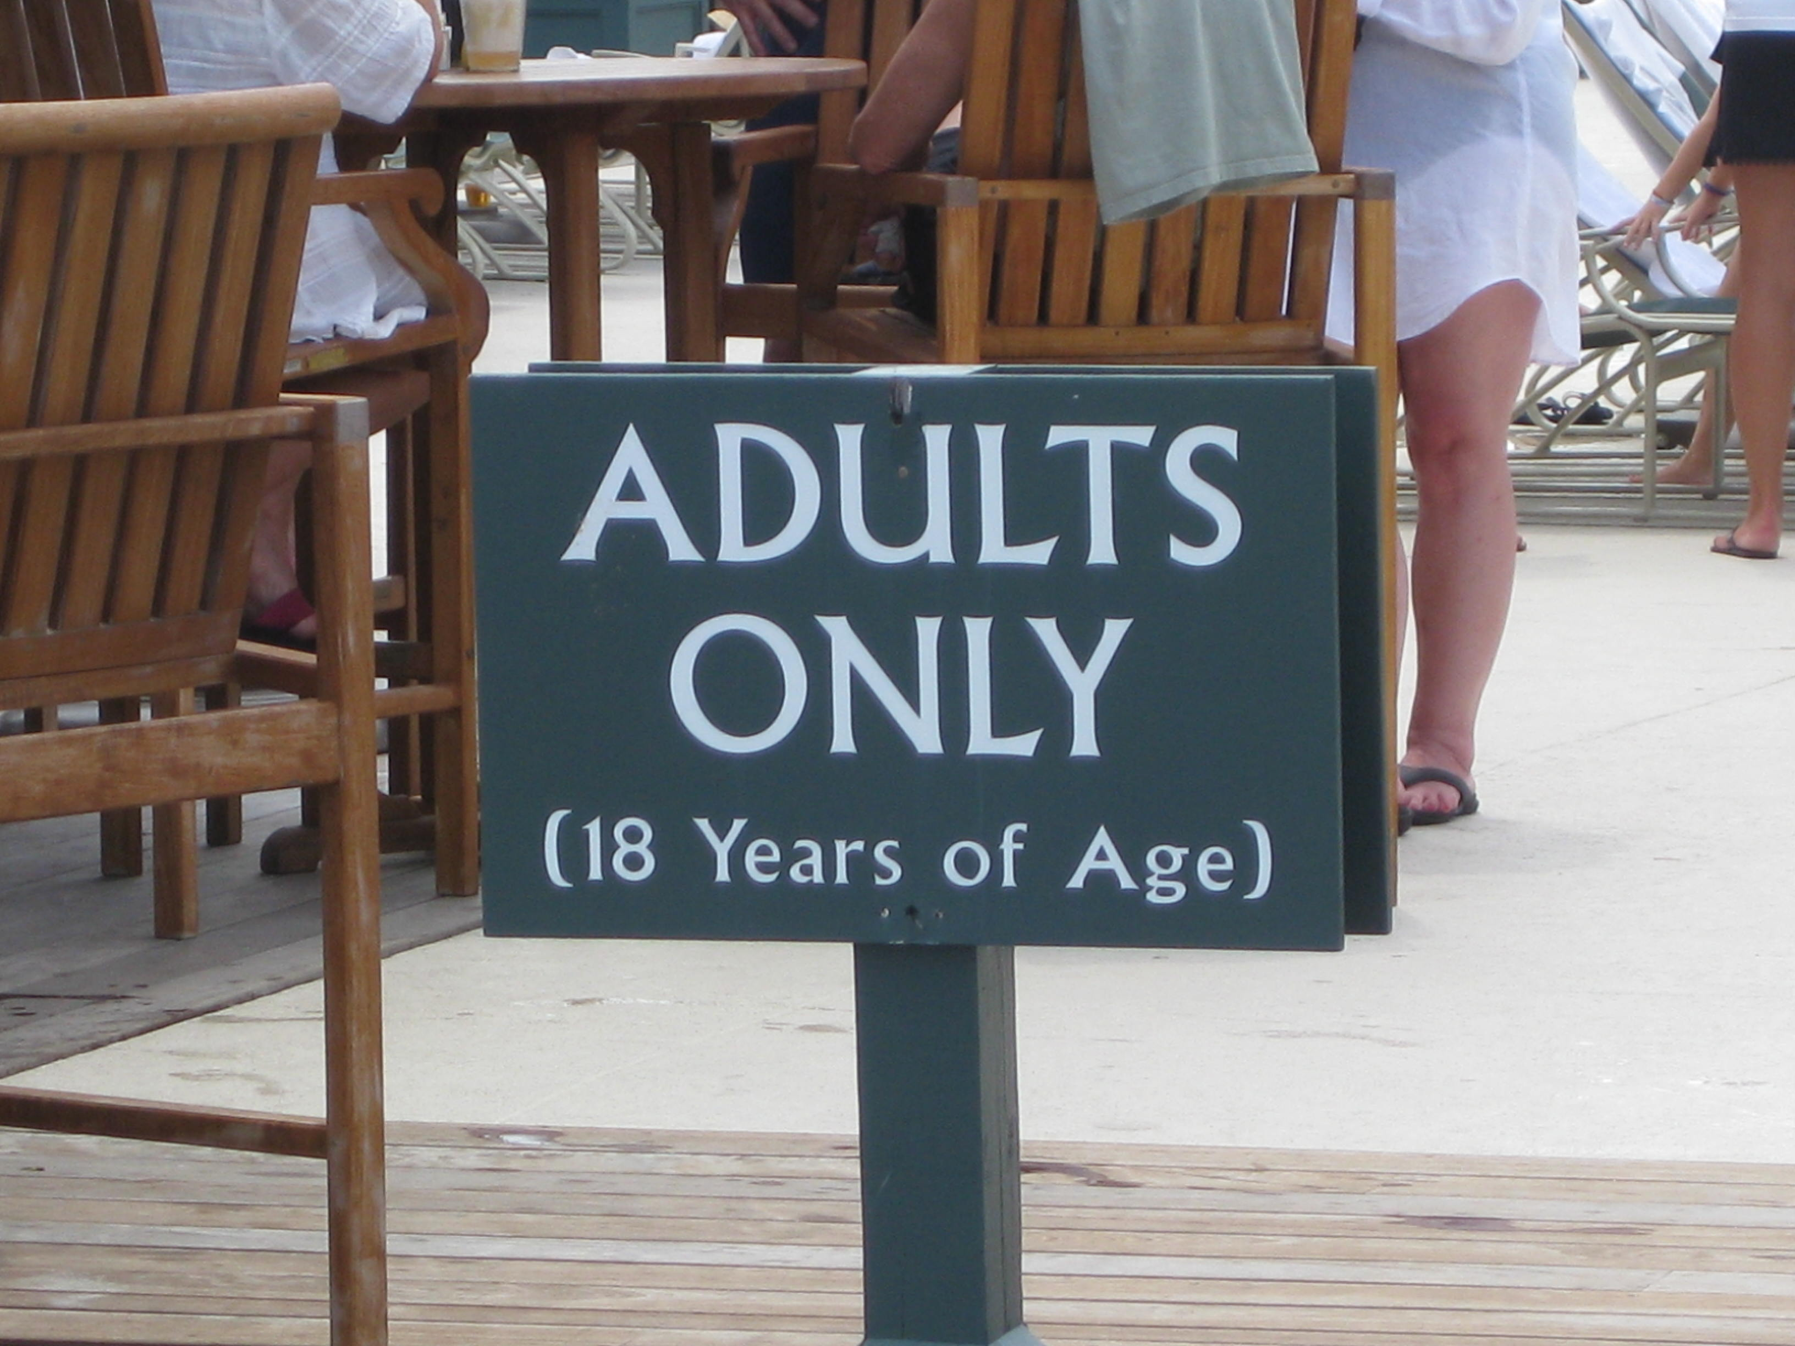
- Age… People who marry ___________________________________________________ report
more satisfaction
- Children…Having a _______________________________________________________________________
- Homogamy… ___________________________________________ (family income,
educational level of parents and of couple, religion, race, ethnicity) also helps
- Lifestyle… __________________________________________________________________about lifestyle is a factor
- Stage of Marriage… The ___________________________________________ sited as more satisfactory
- Reality Based… Partner is ______________________________________________ rather than idealized or romanticized
- Communication… ____________________________________________________________ improve satisfaction
- Conflict Resolution Style… Couples who are more successful
often ______________________ ________________________ through ____________________
_________________________ rather than enforcement, acquiescence or
withdrawal
- Marital Scripts… Understanding how marital scripts
work is important. They are ____________________________________________
____________________________________________________ that are often based on ________________________________________________ and therefore are possibly
different for two people in the same relationship.
Differences in marital scripts can be a _________________________
______________________________________________________________________________________

______________________________________________________________________________________

