NFL star Adrian Peterson arrested
for child abuse
An American football player has been arrested in Texas for allegedly hitting his young child with a tree branch.
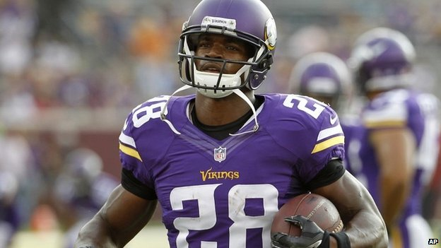Adrian Peterson, who plays for NFL side Minnesota Vikings, turned himself in to the authorities early on Saturday.
Hours earlier he had been charged with reckless or negligent injury to a child, and he is now being held on a $15,000 ( £9,000) bond.
Mr Peterson's attorney said he regretted the incident and never intended to harm the four-year-old.
He said the sportsman "used his judgement as a parent to discipline his son."
The allegations come just days after another NFL star had his contract terminated for hitting his wife.

'Whooping'
According to US media reports, the incident involving Mr Peterson happened in the town of Spring, Texas, in May.
The footballer is said to have punished his son after he pushed another of his children off a motorbike video game.
Local media said the "whooping" - which is how Mr Peterson allegedly referred to the incident during a police interview - resulted in cuts and bruises to the boy's back, buttocks, legs and scrotum.
Mr Hardin said his client was a "loving father" who had "used the same kind of discipline with his child that he experienced as a child growing up in east Texas".
"It is important to remember that Adrian never intended to harm his son and deeply regrets the unintentional injury," he added.
The Minnesota Vikings said Mr Peterson would not be selected to play in Sunday's game against the New England Patriots.

