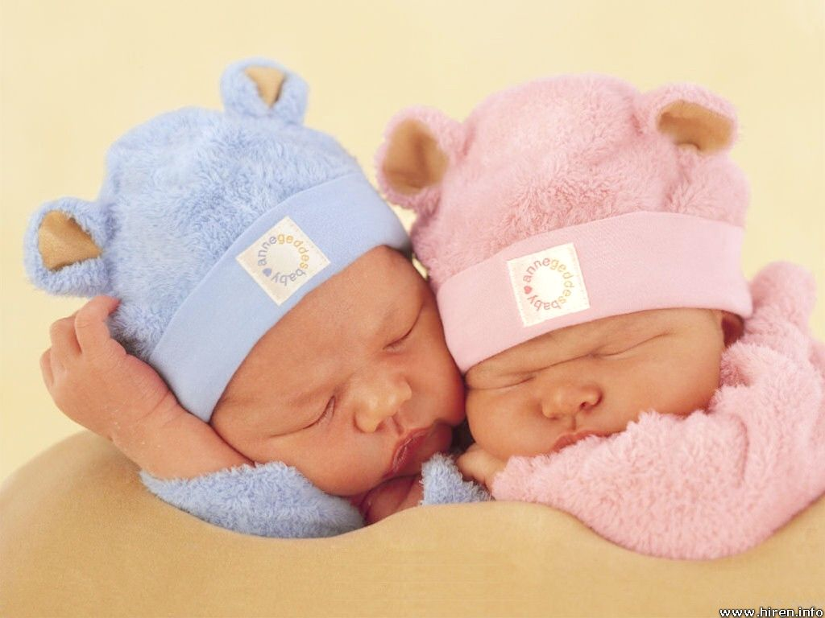
Parenting Trends
FERTILITY . DECISIONS . INFERTILITY . CHILDFREE . ADOPTION

CHILDREN
- _____% of Canadians say they plan on having children
- It is a major stage in the family life cycle framework
- It is a lifetime commitment that should _______________________________
- In Canada, we value children for emotional and social reasons (not directly economic)
- According to the social exchange theory, people have children to fulfill psychological and emotional needs
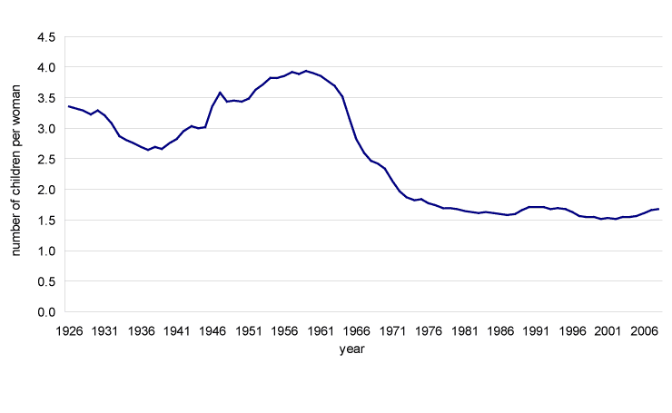
    - Couples expect to receive something back from their children in exchange for time, energy, and money put into raising them

FERTILITY TRENDS
- Currently in Canada the fertility rate [1.6] is below replacement levels, we are not having enough children to replace ourselves [2.1]

When did the rates change in major ways? Why?

1930s ______________________________________
1946 _______________________________________
1960s ______________________________________
1970s + ______________________________________________

TRENDS BY AGE GROUPS

Who is having babies in Canada and at what age? Which groups are declining? ________________________________

Which groups are increasing? _________________________________
Why? ___________________________________________________________________________
_______________________________________________________________________________
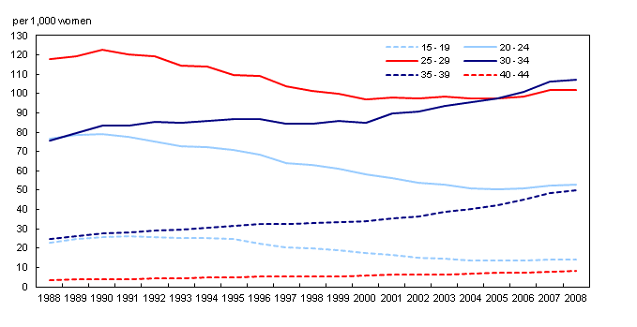

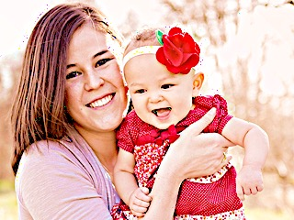
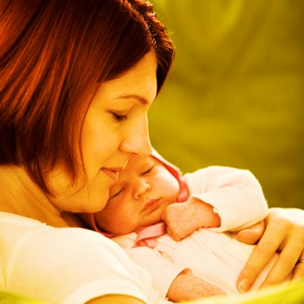
DELAYED PARENTHOOD
- There has been a shift since 1971,
    - an overall decrease in women having children in their ____s,
    - an increase of women having children in their ____s.

- Delayed parenthood – having children ______________________________________
has affected our fertility rate, because when women start later they have a shorter
reproductive period
- Fertility declines with age, it is _________________to get pregnant when you start later – this has lead to higher levels of infertility and couples using assisted reproduction methods
    - Eventually grandparents and parents will outnumber children

DECISIONS DECISIONS
THE COUPLE FACTOR
- Today couples choose when and if to have children
- Most children in Canada today were / are ____________________
- Most couples have ___________________ children than they would like
- Couples surveyed unanimously agreed that there are three
essential factors to consider when planning to have children
  - Having enough ____________for them
  - Recognizing the responsibilities __________________
  - Strength of the ___________________
- More than ever before, today couples are asking themselves,
will having a child make me / us happier and if the answer is yes, then they
have children

- Having said that, young adults today want to __________ their children the experience of having divorced parents, so the quality of the couples’ relationship is a very serious determinant

ECONOMICS FACTOR
- Finances were identified by ____% of young adults surveyed – it is more important though to those who do not have children
- However, even though it is estimated to cost about ________________ dollars a year to raise a child, people with lower income are having more children than those with higher incomes
- Dual income couples have more money but feel they can’t afford
to take the time off needed to have several babies, or to _________________________
- Paternity benefits are _____% of your salary
- Many couples weigh the social and financial _____________________________ of
becoming a parent when making this decision

INFERTILITY
- Some couples find out when they are ready to have a baby
that it isn’t as easy as they thought it might be
- 7% of young couples are likely __________________
- At age 30 - _____% of women can conceive
- At age 40 this drops to _____%

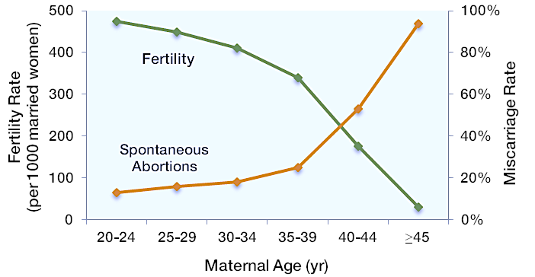
So, the older women get the more often

they will __________________________

Spontaneous abortion is the medical term for a miscarriage

SAME SEX COUPLES
- Same sex couples are considering parenthood more today than in the past
- Some have children from former heterosexual relationships
- As of 2006 _____% of same sex couples have children under 24 living with them
- There is a struggle for equal rights, for example
prior to 2009 a ______________________ mom did not have the same legal rights as the _________________ mom
- Similar factors that heterosexual couples consider when deciding to parent influence same sex couples, except that it can be more difficult for same sex couples to become parents
- Lesbians can use sperm donors but gay men need to adopt or use ___________________
- Stigma and prejudice can also _______________ same sex couples

CHILDFREE OR CHILDLESS
- Some (minority) decide to intentionally remain childfree
- 7% of adults under 25 years of age state they do not intend to have
children
- 15% of those under 44 don’t have children
- By choice prefer the term ____________________
- Not by choice prefer the term _______________________
- Some couples decide early on while others make the decision
gradually
- Using the exchange theory, the benefits probably don’t outweigh the perceived costs

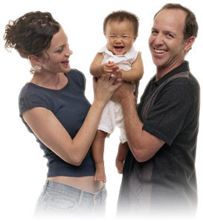
ADOPTION
- The number of Canadian children place for adoption has ______________________
over the past 2 decades
- Currently about ____________ domestic adoptions take place per year
- There are few infants available
- Most children placed are older
- __________________________adoptions count for 1500 to 2000 adoptions in
Canada since 1997
- In 2008 1908 international adoptions happened
    - ____% of these were girls from China

