The Transition to Adulthood in the Past &
The Transition to Adulthood in Canada Today
Transition to Adulthood
in Canada today
- ________________ is the period that follows __________________________(after childhood) and lasts until death
- it is ___________________________________ rather than marked by a single event
- legally the age of majority begins at age _______
- however, __________________________________________…
- adult status = adult ____________________________________________________
  - separating from his ______________________________________________
  - starting her _____________________________________________________
  - leaving _________________________________________________________
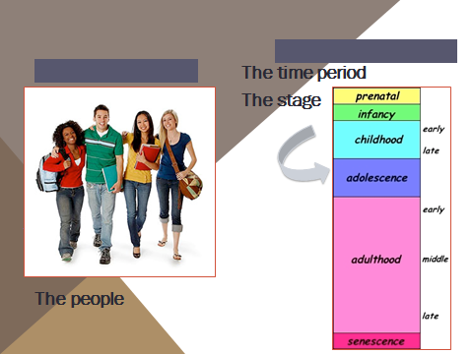
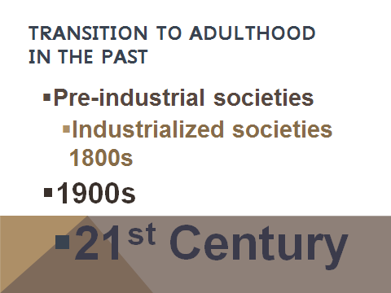
Pre-industrial societies
- The stage of adolescence did not exist, children ____________ till around ___ and then considered work ready and known __________ till they married and lived on own – typically mid to late twenties
  - Lower class girls became domestic servants and boys became labourers or apprentices, while upper class children were educated at home
  - Working class youth left home early and lived semi-independently
- High infant mortality rates saw __________ of children dying before the age of 20
Industrialized societies 1800s
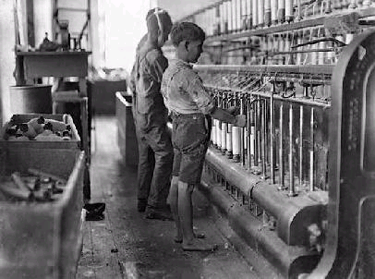
- Families could live in cities and youth could ____________________________________
- Fathers could take sons and daughters to work with
them and typically maintained control over them until they turned 17 (collecting their earnings)
- _______________________ (factory & business owners) adolescent daughters were educated at home, sons were sent away to school
- Youth tended to leave after 17 to board on their own and remained on their own until they married around the age of 24 typically

the 1900s
- were a century of change for the family, child labour laws introduced to prevent child labour
- ________________________ was established
- as the century progressed youth stayed in school for longer and longer 14 - 16 – 18 (working class youth have a harder time staying in school throughout)
- post secondary attendance increased
- the term adolescence is used to identify children who had reached puberty but were not yet in the workforce
- Increase in schooling period = more leisure and preparation time = longer transition period to adulthood
_______________________________________________
21st Century
the period of ______________________________, financial and emotional dependence on
parents is increasing
- leaving school, starting work, leaving home and getting married happening
______________________________________________________________________
- increase in school time coincides with a decrease in work opportunities
- young people end up ________________________ from taking on adult roles & becoming independent because of a lack of good jobs
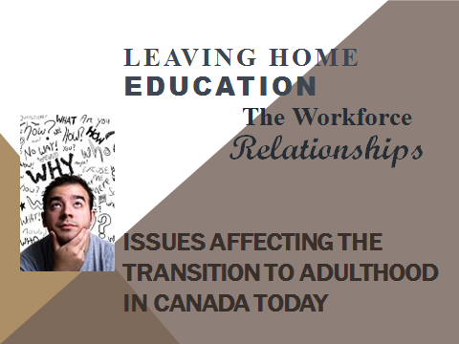
Leaving Home
Today living ____________________________ * alone or with flat mates typically precedes cohabitation or marriage.

- in the 1800s puberty preceded full physical maturity by a shorter period
- today sexual maturity occurs ______________ before full physical maturity
- yet, marriage & family are occurring _____________r [the majority of 24 year olds still live at home 7/10]
Should I stay or should I go?
____________________________________ can be used to understand how young adults weigh costs and benefits of staying or leaving
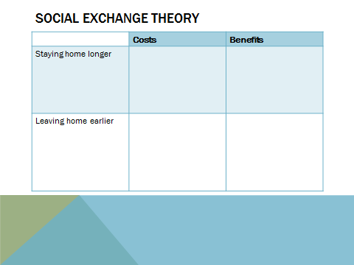
What are some of the costs of leaving, or of staying, and what are some of the benefits of leaving or of staying?

DYK Children of lower income parents or divorced parents are __________________ to leave home earlier, ______________leave earlier, men and children of higher income parents tend to stay _____________
Not leaving home early enough has been termed ________________________
Education
- there has been an increased emphasis on ____________ education over the last 50 years,
  - 60s and 70s introduced ____________________educating the most number of people possible including those whose abilities may have reduced their chances of being successful in the past. [Streams are ____________________________ ]
- Post-secondary education opportunities also increased in __________________, with emphasis in the past few decades on work place training > _______________________ [less emphasis on education for interest or knowledge sake]
- Past – ________________ have post-secondary education
Present – ________________ have post-secondary education
- _________________________ > we need _____________education today to get a job than was needed in past, but ______________________________________________
_______________________________________________________________________
The Workforce
- income is connected to _________________________________
- career choice is important to ________________________________________
- the workplace has changed
  - it is becoming more ____________________________
  - the economy dropped in the 90s, forcing ____________________________ to increase
  - it is recovering now – ___________________________________________in 2007, but there are a lot of _______________________________________________________ that had been expected to retire
  - fewer opportunities =________________________________________________
Relationships
- relationships ______________________________ __________________support young adults making the transition
- teens value personal relationships _____________ important to happiness
- teens who are encouraged to ________________ = ___________________________ relationship
- ___________________________ can be used to understand that the whole family system has to adjust to allow the young adult to change (both family and young adult adjust)
- What sort of changes would a young adult need to make as they transition into adulthood?
________________________________________________________________________________________________________________________________________________________________________________________________________________________________________________________________________________________
- What sort of changes would a family of the young adult need to make as their youth transitions into adulthood?
________________________________________________________________________________________________________________________________________________________________________________________________________________________________________________________________________________________
- Workplace relationships for young adults often present _______________________

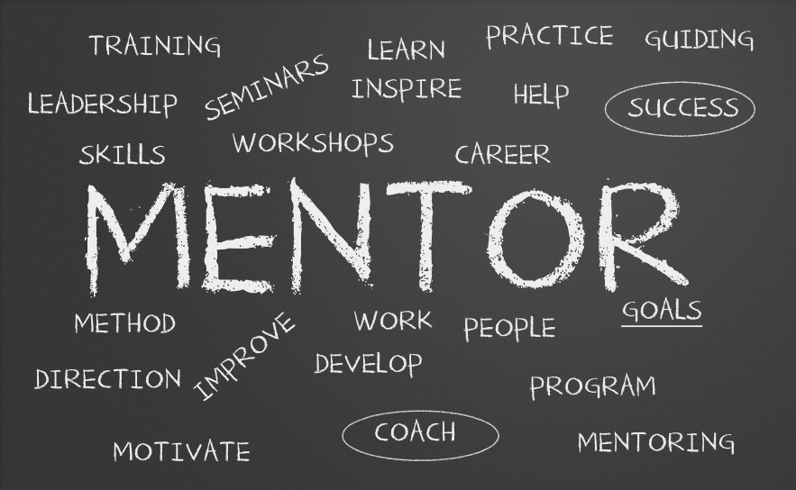
- ________________ relationships can be helpful (an older person in the work place who helps teach the system, values, expectations, knowledge & skills)
- Focus also turns to fostering an ___________________ relationship and looking for a partner

This transition takes years _____________, ________________ goals and ________________________ are key assets

SUCCESSFUL TRANSITIONS ARE THE GOAL…
Consolidation
Which of these challenges or factors seems the most daunting to you?
________________________________________________________________________________________________________________________________________________________
Which of these challenges or factors seems the most rewarding to you?
________________________________________________________________________________________________________________________________________________________
What is one piece of advice you would give to a younger sibling about making this transition, based on what you know so far?
____________________________________________________________________________________________________________________________________________________________________________________________________________________________________

